CIA 1: Component 1- Assignment

Operating System

Submitted to: Smera C

An Operating System provides an interaction between the users and computer hardware. A user is a person sitting at the computer terminal concerned about the application rather than the architecture of the computer. The user never interacts with the hardware directly. To get the services of the hardware, he has to request through the operating system.

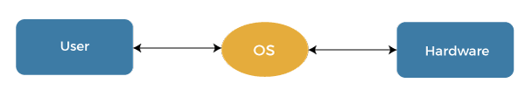

The operating system is a primary resource manager. It manages the hardware, including processors, memory, Input-Output devices, and communication devices.

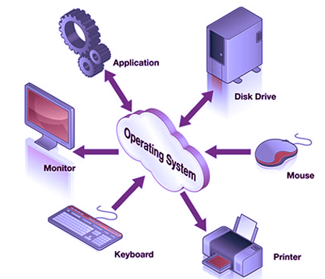

1. **Operating System Services**

The operating system provides the programming environment in which a programmer works on a computer system. The user program requests various resources through the operating system. The operating system gives several services to utility programmers and users. Applications access these services through application programming interfaces or system calls. By invoking those interfaces, the application can request a service from the operating system, pass parameters, and acquire the operation outcomes.

**Following are the services provided by an operating system -**

* Program execution
* Control Input/output devices
* Program creation
* Error Detection and Response
* Accounting
* Security and Protection
* File Management
* Communication

**Program execution**

To execute a program, several tasks need to be performed. Both the instructions and data must be loaded into the main memory. In addition, input-output devices and files should be initialized, and other resources must be prepared. The Operating structures handle these kinds of tasks. The user now no longer should fear the reminiscence allocation or multitasking or anything.

**Control Input/output devices**

As there are numerous types of I/O devices within the computer system, and each I/O device calls for its own precise set of instructions for the operation. The Operating System hides that info with the aid of presenting a uniform interface. Thus, it is convenient for programmers to access such devices easily.

**Program Creation**

The Operating system offers the structures and tools, including editors and debuggers, to help the programmer create, modify, and debugging programs.

**Error Detection and Response**

An Error in a device may also cause malfunctioning of the entire device. These include hardware and software errors such as device failure, memory error, division by zero, attempts to access forbidden memory locations, etc. To avoid error, the operating system monitors the system for detecting errors and takes suitable action with at least impact on running applications.

While working with computers, errors may occur quite often. Errors may occur in the:

* **Input/ Output devices:** For example, connection failure in the network, lack of paper in the printer, etc.
* **User program:** For example: attempt to access illegal memory locations, divide by zero, use too much CPU time, etc.
* **Memory hardware:** For example, Memory error, the memory becomes full, etc.

To handle these errors and other types of possible errors, the operating system takes appropriate action and generates messages to ensure correct and consistent computing.

**Accounting**

An Operating device collects utilization records for numerous assets and tracks the overall performance parameters and responsive time to enhance overall performance. These personal records are beneficial for additional upgrades and tuning the device to enhance overall performance.

**Security and Protection**

Operating device affords safety to the statistics and packages of a person and protects any interference from unauthorized users. The safety feature counters threats, which are published via way of individuals out of doors the manage of the running device.

**For Example:**

When a user downloads something from the internet, that program may contain malicious code that may harm the already existing programs. The operating system ensures that proper checks are applied while downloading such programs.

If one computer system is shared amongst a couple of users, then the various processes must be protected from another intrusion. For this, the operating system provides various mechanisms that allow only those processes to use resources that have gained proper authorization from the operating system. The mechanism may include providing unique users ids and passwords to each user.

**File management**

Computers keep data and information on secondary storage devices like magnetic tape, magnetic disk, optical disk, etc. Each storage media has its capabilities like speed, capacity, data transfer rate, and data access methods.

For file management, the operating system must know the types of different files and the characteristics of different storage devices. It has to offer the proportion and safety mechanism of documents additionally.

**Communication**

The operating system manages the exchange of data and programs among different computers connected over a network. This communication is accomplished using message passing and shared memory.

1. **System Calls**

A system call is a method for a computer program to request a service from the kernel of the operating system on which it is running. A system call is a method of interacting with the operating system via programs. A system call is a request from computer software to an operating system's kernel.

The Application Program Interface (API) connects the operating system's functions to user programs. It acts as a link between the operating system and a process, allowing user-level programs to request operating system services. The kernel system can only be accessed using system calls. System calls are required for any programs that use resources.

## **How are system calls made?**

When a computer software needs to access the operating system's kernel, it makes a system call. The system call uses an API to expose the operating system's services to user programs. It is the only method to access the kernel system. All programs or processes that require resources for execution must use system calls, as they serve as an interface between the operating system and user programs.

Below are some examples of how a system call varies from a user function.

1. A system call function may create and use kernel processes to execute the asynchronous processing.
2. A system call has greater authority than a standard subroutine. A system call with kernel-mode privilege executes in the kernel protection domain.
3. System calls are not permitted to use shared libraries or any symbols that are not present in the kernel protection domain.
4. The code and data for system calls are stored in global kernel memory.

## **Why do you need system calls in Operating System?**

There are various situations where you must require system calls in the operating system. Following of the situations are as follows:

1. It is must require when a file system wants to create or delete a file.
2. Network connections require the system calls to sending and receiving data packets.
3. If you want to read or write a file, you need to system calls.
4. If you want to access hardware devices, including a printer, scanner, you need a system call.
5. System calls are used to create and manage new processes.

## **Types of System Calls**

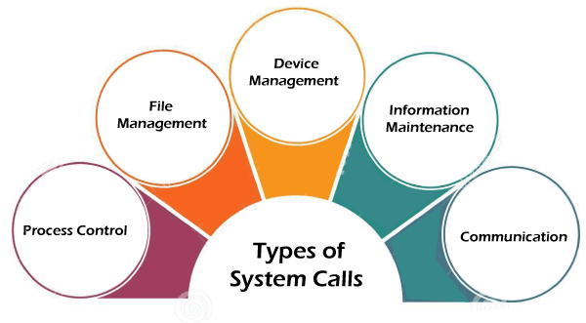There are commonly five types of system calls. These are as follows:

1. **Process Control**
2. **File Management**
3. **Device Management**
4. **Information Maintenance**
5. **Communication**

Now, you will learn about all the different types of system calls one-by-one.

### **Process Control**

Process control is the system call that is used to direct the processes. Some process control examples include creating, load, abort, end, execute, process, terminate the process, etc.

### **File Management**

File management is a system call that is used to handle the files. Some file management examples include creating files, delete files, open, close, read, write, etc.

### **Device Management**

Device management is a system call that is used to deal with devices. Some examples of device management include read, device, write, get device attributes, release device, etc.

### **Information Maintenance**

Information maintenance is a system call that is used to maintain information. There are some examples of information maintenance, including getting system data, set time or date, get time or date, set system data, etc.

### **Communication**

Communication is a system call that is used for communication. There are some examples of communication, including create, delete communication connections, send, receive messages, etc.

1. **Linkers and loaders**

Linker

* The main function of the linker is to generate executable files.
* The linker takes the input as the object code which would be generated by a compiler/assembler.
* The process of linking can be understood as a method to combine different snippets of code in order to obtain executable code.
* There are two types of linkers available: Linkage Editor and Dynamic Linker.
* Linker also helps combine all the object modules.
* Linker is responsible to arrange the objects in the program’s address space.

Loader

* The main function of a loader is to load executable files to the main memory.
* It takes the executable files (generated by linker) as its input.
* It can be understood as a process of loading the executable codes into main memory where it is execute further.
* There are 3 types of loaders: Absolute loading, Relocatable loading and Dynamic run-time loading.
* It helps allocate the addresses to executable codes or files.
* It is also responsible to adjust the references that are used within the program.

1. **Structure of a WINDOWS Operating System and Recent updates in the operating system.**

The Windows operating system has a layered architecture, with different components handling various tasks.

1. **Kernel:**
   * The core of the operating system.
   * Manages memory, processes, and hardware interactions.
   * Provides essential services for other parts of the operating system.
2. **Hardware Abstraction Layer (HAL):**
   * Bridges the gap between the kernel and the hardware.
   * Allows the kernel to communicate with different types of hardware without needing to know specific details about each device.
3. **Executive Services:**
   * Includes various system services such as process management, I/O, and security.
   * Implements the Windows API (Application Programming Interface), allowing applications to interact with the operating system.
4. **User Mode and Kernel Mode:**
   * Windows operates in two modes: user mode and kernel mode.
   * User mode is where applications run, and they have limited access to system resources.
   * Kernel mode is where the operating system executes and has full access to system resources.
5. **Device Drivers:**
   * Interface between the operating system and hardware devices.
   * Allow the kernel to communicate with specific hardware components.
6. **User Interface:**
   * Includes the graphical user interface (GUI) and the Windows Explorer shell.
   * Provides the desktop environment, start menu, and other user-facing elements.

**Recent Update:**

Windows 11 2023 Update

As announced in July, the Windows 11 2023 Update (version 23H2) will be released in the fourth quarter of 2023. This new update will have the same servicing branch and code base as Windows 11, version 22H2 and will be cumulative with all the newly announced features. For devices on version 22H2, the 2023 Update will be delivered via a small enablement package (eKB)7. This continues the annual feature update cadence, with new feature updates released in the second half of the calendar year. This new version resets the 24 months of support for Home and Pro editions and 36 months of support for Enterprise and Education editions.

**Windows 11 Highlights:**

* **Redesigned Start Menu and Taskbar:** Windows 11 introduced a centered Start Menu and a simplified, more modern taskbar.
* **Snap Layouts and Snap Groups:** Improved window management features for multitasking, making it easier to organize and switch between open applications.
* **Direct integration with Microsoft Teams:** Windows 11 comes with Microsoft Teams integration directly into the taskbar, promoting seamless communication and collaboration.
* **New Microsoft Store:** The Microsoft Store was redesigned for a better user experience, with a focus on a wider range of apps, including support for Android apps.
* **Performance Improvements:** Windows 11 was designed to offer better performance and efficiency, with optimizations for newer hardware.